Firmware Flashing Method

1.Connect the computer and Anchor together using USB-TTL.
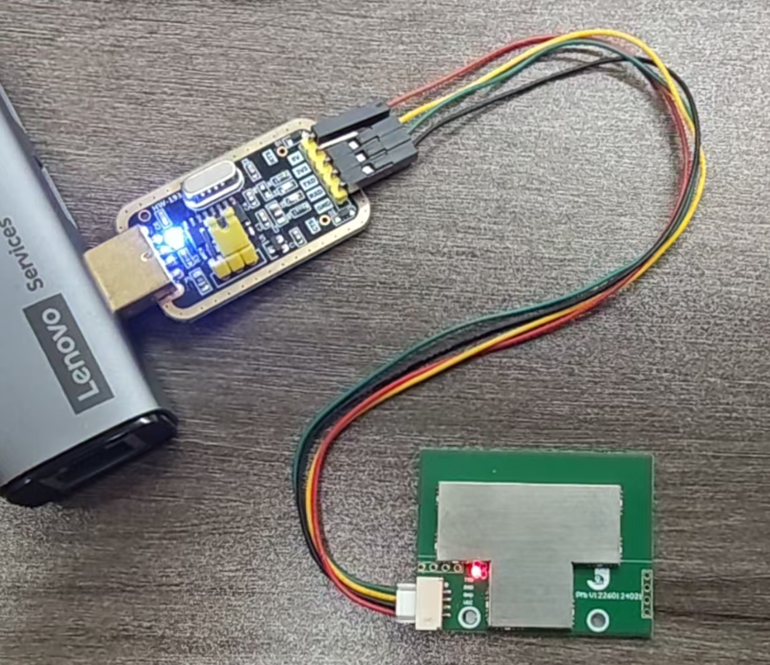

2.Open & Connect MaUWB_Assistant.exe
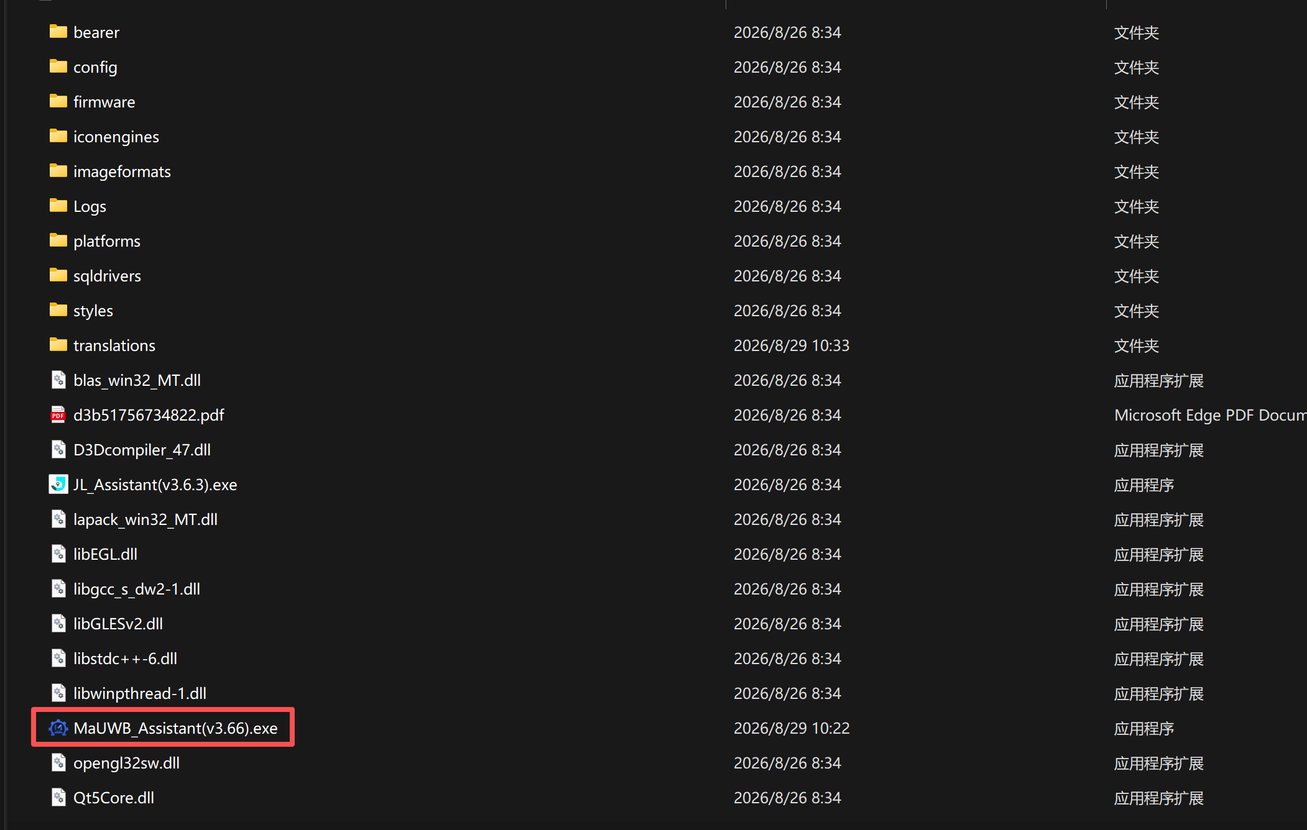
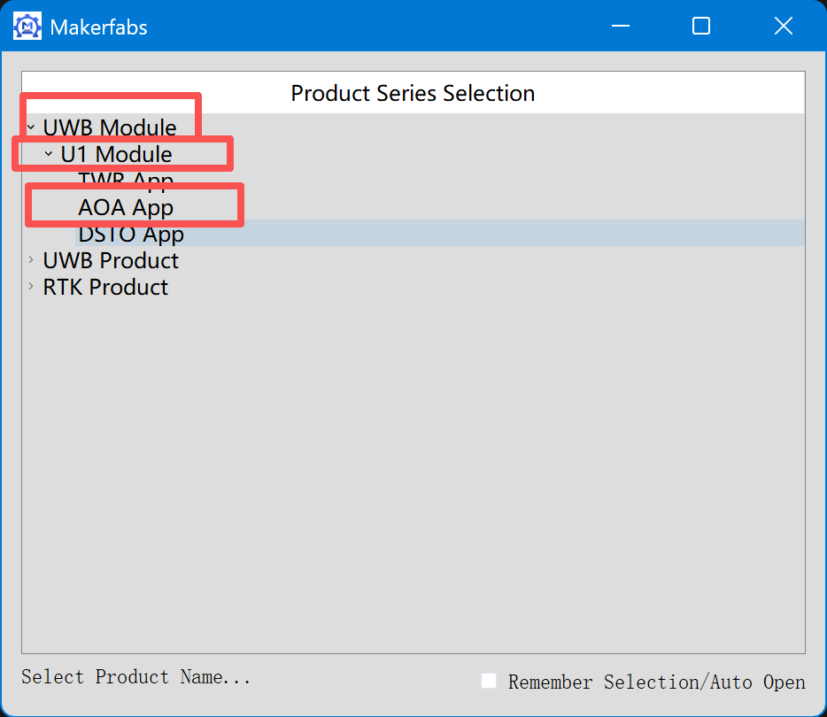
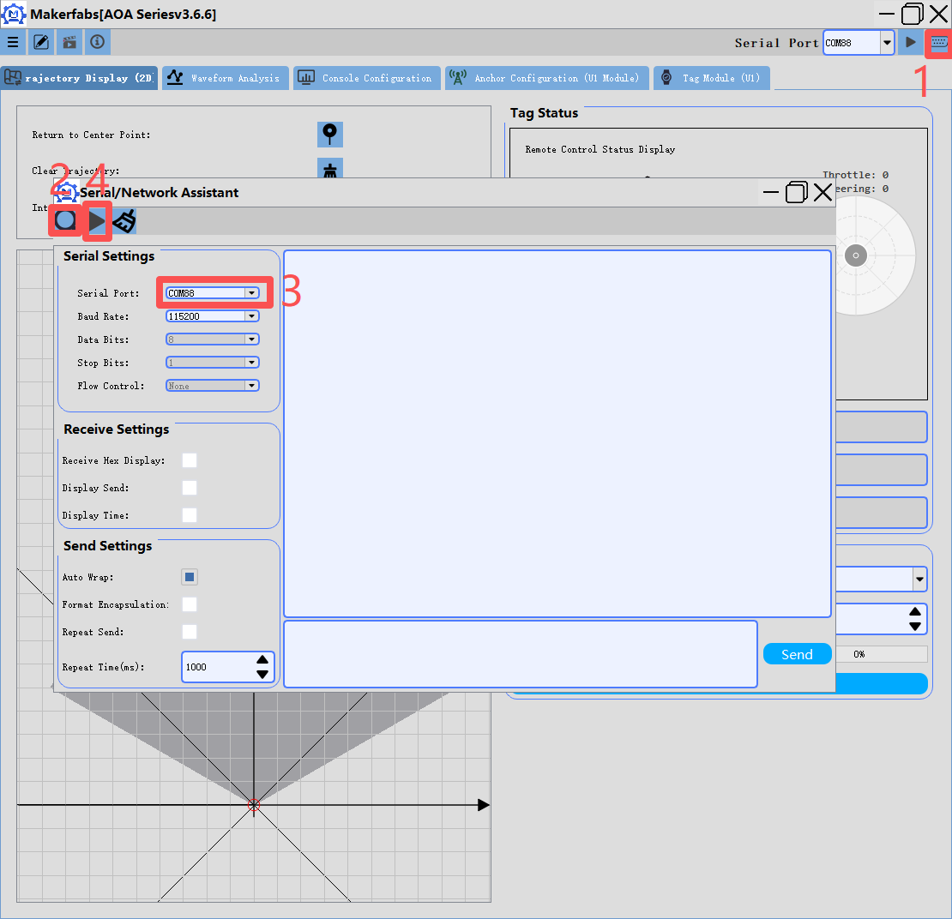
Note: When the data is reported, it will show as garbled characters in the [Serial/Network Assistant] section. This data is not garbled but rather hexadecimal data.
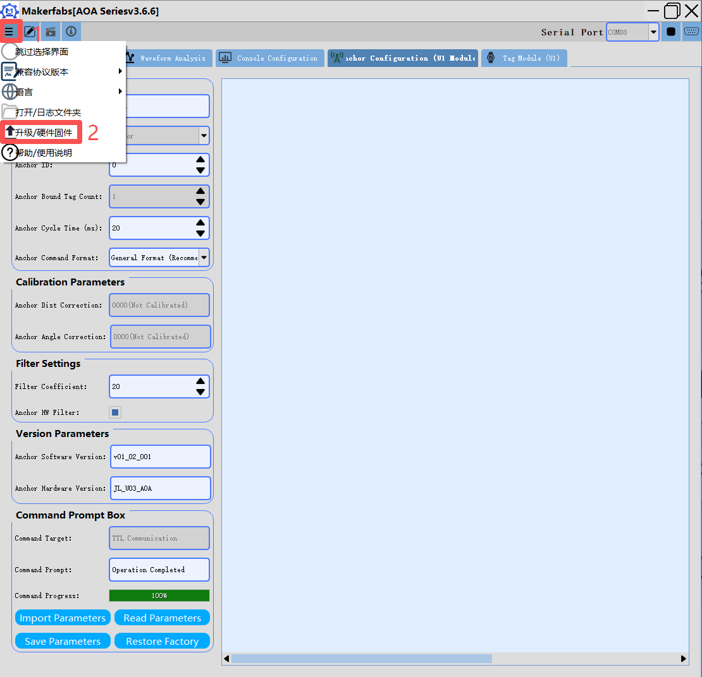

3.Download the corresponding bin file from GitHub
MaUWB_AOA-Gen2/datasheet/Anchor/bin at main · Makerfabs/MaUWB_AOA-Gen2

4.Select the corresponding firmware for flashing.
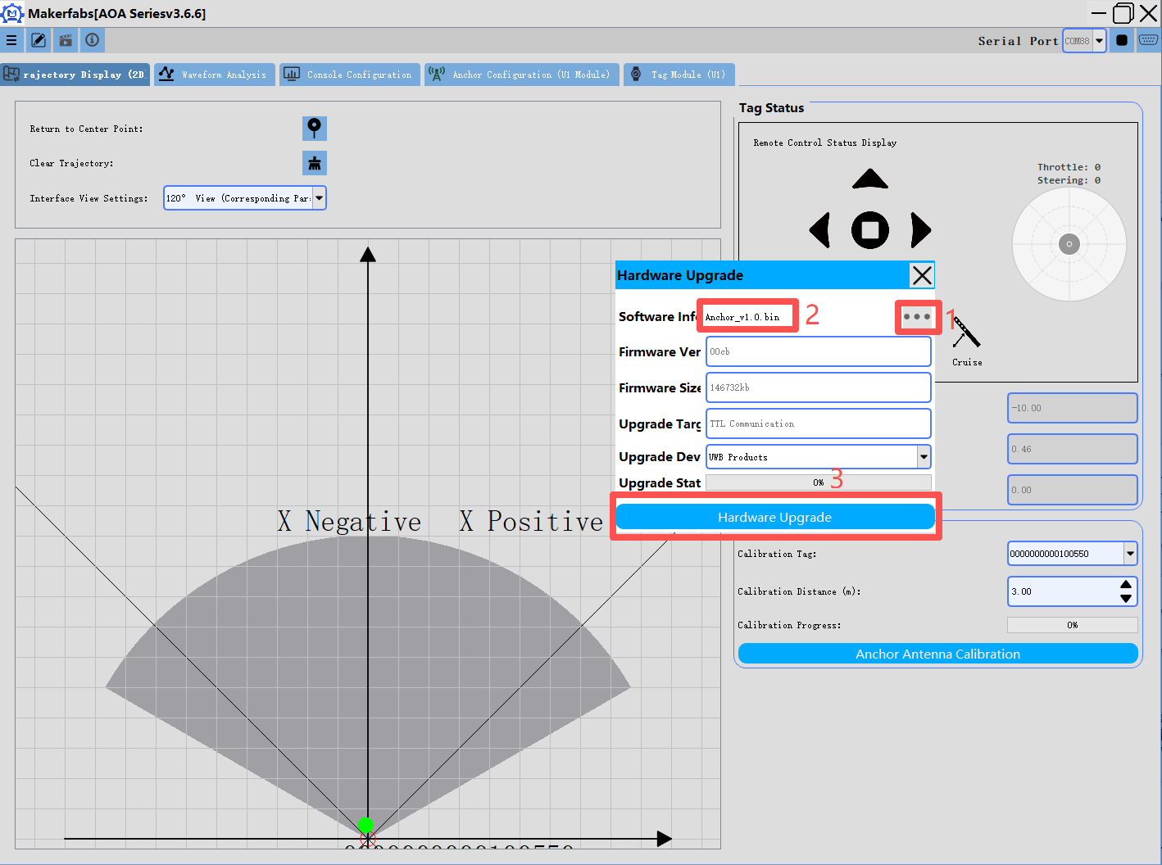

5.The firmware flashing method for the tags is the same.
Tag Wiring Instructions: Connect tag VCC to USB-TTL 3.3V, tag GND to USB-TTL GND. Connect tag TX to USB-TTL RX and tag RX to USB-TTL TX.

